Worksheet on multiple regression
Andrew Smith
2026-03-17

Multiple regression models
- We will use the ‘mtcars’ dataset that we saw when we studied simple linear regression. It is a built-in dataset in R: there is no need to load it.
- Dependent variable is ‘mpg’
- Independent variables are drawn from all other variables in the dataset

Reminder of simple linear regression model
In the last exercise of the simple linear regression worksheet, we looked for plots and linear correlations within the continuous variables of mtcars:
df <- mtcars %>% # make data frame containing only variables we know to be continuous
dplyr::select(-c(am, vs, cyl, gear, carb)) # need to use dplyr::select to distinguish from the function called 'select' in the MASS package
plot(df) # plot the continuous variables against each other
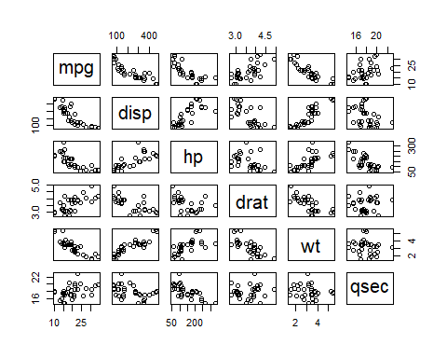
corrs <- cor(df) # calculate correlation coefficients
library(corrplot)
## corrplot 0.95 loaded
corrplot(corrs, method="number")
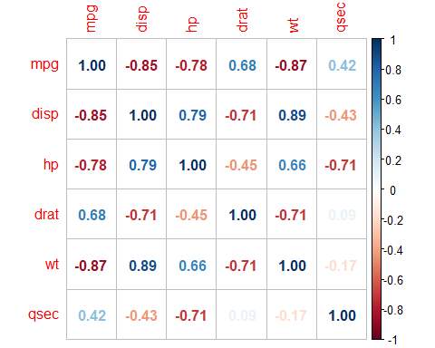
We found that wt had the strongest correlation with mpg, and fitted a simple linear regression model:
model_1 <- lm(mpg ~ wt, data=mtcars)
summary(model_1)
##
## Call:
## lm(formula = mpg ~ wt, data = mtcars)
##
## Residuals:
## Min 1Q Median 3Q Max
## -4.5432 -2.3647 -0.1252 1.4096 6.8727
##
## Coefficients:
## Estimate Std. Error t value Pr(>|t|)
## (Intercept) 37.2851 1.8776 19.858 < 2e-16 ***
## wt -5.3445 0.5591 -9.559 1.29e-10 ***
## ---
## Signif. codes: 0 '***' 0.001 '**' 0.01 '*' 0.05 '.' 0.1 ' ' 1
##
## Residual standard error: 3.046 on 30 degrees of freedom
## Multiple R-squared: 0.7528, Adjusted R-squared: 0.7446
## F-statistic: 91.38 on 1 and 30 DF, p-value: 1.294e-10
- Notice R-squared = 0.7528. Means this model explains XX% of variation in mpg
- Notice p-value for whole model (1.294e-10) equals the p-value for the coefficient of wt
library(performance)
check_model(model_1)
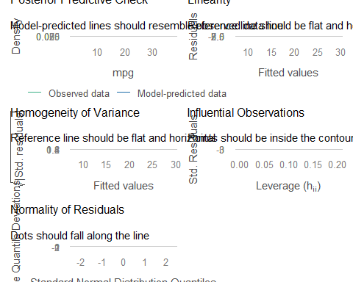

Model with two independent variables
Now try a model with two independent variables. Let’s regress mpg on wt and hp
model_2 <- lm(mpg ~ wt + hp, data=mtcars)
summary(model_2)
##
## Call:
## lm(formula = mpg ~ wt + hp, data = mtcars)
##
## Residuals:
## Min 1Q Median 3Q Max
## -3.941 -1.600 -0.182 1.050 5.854
##
## Coefficients:
## Estimate Std. Error t value Pr(>|t|)
## (Intercept) 37.22727 1.59879 23.285 < 2e-16 ***
## wt -3.87783 0.63273 -6.129 1.12e-06 ***
## hp -0.03177 0.00903 -3.519 0.00145 **
## ---
## Signif. codes: 0 '***' 0.001 '**' 0.01 '*' 0.05 '.' 0.1 ' ' 1
##
## Residual standard error: 2.593 on 29 degrees of freedom
## Multiple R-squared: 0.8268, Adjusted R-squared: 0.8148
## F-statistic: 69.21 on 2 and 29 DF, p-value: 9.109e-12
- Notice R-squared has gone up. This model with two independent variables explains XX% of variation in mpg
- Now we have a p-value for each coefficient, and they do not correspond to the p-value for the whole model (9.109e-12)
check_model(model_2)
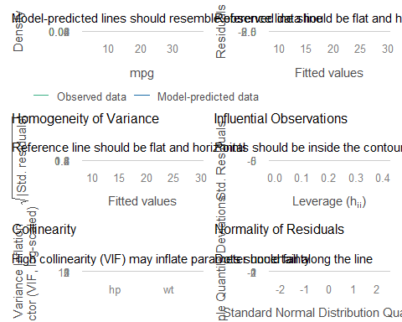

Full model
What if we put in the full amount of independent variables?
- We would expect to be able to explain a large amount of variation in mpg, so why not put in all the independent variables we can!?
- If using all independent variables, would want to make sure we remove rows with NA values.
mtcars <- na.omit(mtcars) # removes rows with NA values, if there are any
model_full <- lm(mpg ~ ., data=mtcars)
summary(model_full)
##
## Call:
## lm(formula = mpg ~ ., data = mtcars)
##
## Residuals:
## Min 1Q Median 3Q Max
## -3.4506 -1.6044 -0.1196 1.2193 4.6271
##
## Coefficients:
## Estimate Std. Error t value Pr(>|t|)
## (Intercept) 12.30337 18.71788 0.657 0.5181
## cyl -0.11144 1.04502 -0.107 0.9161
## disp 0.01334 0.01786 0.747 0.4635
## hp -0.02148 0.02177 -0.987 0.3350
## drat 0.78711 1.63537 0.481 0.6353
## wt -3.71530 1.89441 -1.961 0.0633 .
## qsec 0.82104 0.73084 1.123 0.2739
## vs 0.31776 2.10451 0.151 0.8814
## am 2.52023 2.05665 1.225 0.2340
## gear 0.65541 1.49326 0.439 0.6652
## carb -0.19942 0.82875 -0.241 0.8122
## ---
## Signif. codes: 0 '***' 0.001 '**' 0.01 '*' 0.05 '.' 0.1 ' ' 1
##
## Residual standard error: 2.65 on 21 degrees of freedom
## Multiple R-squared: 0.869, Adjusted R-squared: 0.8066
## F-statistic: 13.93 on 10 and 21 DF, p-value: 3.793e-07
- All the independent variables together explain XX% of variation in mpg
- The p-value for the whole model is significant (3.793e-07) but none of the coefficients are significant!
check_model(model_full)
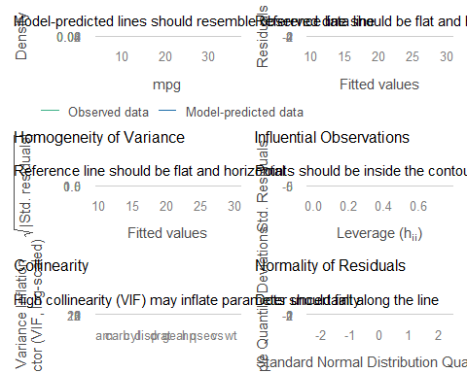
There is a problem with multicollinearity!
- Multicollinearity is caused by correlation between the independent variables.
- We should be careful to check the correlation between the independent (predictor) variables.

Dewis exercise on multiple regression
### Use this code chunk for your code for the multiple regression Dewis exercise

Akaike Information Criterion (AIC)
- We need to remove some independent variables from the full model
- Too many independent variables, and we get multicollinearity problems.
- Too many independent variables, we risk including an independent variable that makes no contribution to the model.
- Need a balance between
  - Having enough independent variables to predict a decent proportion of variation in the dependent variable
  - Not having too many independent variables; not including independent variables that make no contribution.
- One way of achieving this balance is to minimise the AIC
  - Find out more about AIC in the help file ?extractAIC

Null model
Out of interest, fit a model with no independent variables
model_null <- lm(mpg ~ 1, data=mtcars)
summary(model_null)
##
## Call:
## lm(formula = mpg ~ 1, data = mtcars)
##
## Residuals:
## Min 1Q Median 3Q Max
## -9.6906 -4.6656 -0.8906 2.7094 13.8094
##
## Coefficients:
## Estimate Std. Error t value Pr(>|t|)
## (Intercept) 20.091 1.065 18.86 <2e-16 ***
## ---
## Signif. codes: 0 '***' 0.001 '**' 0.01 '*' 0.05 '.' 0.1 ' ' 1
##
## Residual standard error: 6.027 on 31 degrees of freedom
mean(mtcars$mpg)
## [1] 20.09062
- This model just fits the mean. It explains 0% of the variation in mpg

Compare AICs
library(MASS)
##
## Attaching package: 'MASS'
## The following object is masked from 'package:dplyr':
##
## select
extractAIC(model_null)
## [1] 1.0000 115.9434
extractAIC(model_1)
## [1] 2.00000 73.21736
extractAIC(model_2)
## [1] 3.00000 63.84027
extractAIC(model_full)
## [1] 11.00000 70.89774
- It would appear that model_2, the model with wt and hp, is the best balanced model.
- But is there an even better model with a different number of independent variables?
- Use stepwise model selection to find the model with smallest AIC.

Stepwise model selection
# Tell stepAIC to start with the full model, and then save as the final model
model_final <- stepAIC(model_full)
## Start: AIC=70.9
## mpg ~ cyl + disp + hp + drat + wt + qsec + vs + am + gear + carb
##
## Df Sum of Sq RSS AIC
## - cyl 1 0.0799 147.57 68.915
## - vs 1 0.1601 147.66 68.932
## - carb 1 0.4067 147.90 68.986
## - gear 1 1.3531 148.85 69.190
## - drat 1 1.6270 149.12 69.249
## - disp 1 3.9167 151.41 69.736
## - hp 1 6.8399 154.33 70.348
## - qsec 1 8.8641 156.36 70.765
## <none> 147.49 70.898
## - am 1 10.5467 158.04 71.108
## - wt 1 27.0144 174.51 74.280
##
## Step: AIC=68.92
## mpg ~ disp + hp + drat + wt + qsec + vs + am + gear + carb
##
## Df Sum of Sq RSS AIC
## - vs 1 0.2685 147.84 66.973
## - carb 1 0.5201 148.09 67.028
## - gear 1 1.8211 149.40 67.308
## - drat 1 1.9826 149.56 67.342
## - disp 1 3.9009 151.47 67.750
## - hp 1 7.3632 154.94 68.473
## <none> 147.57 68.915
## - qsec 1 10.0933 157.67 69.032
## - am 1 11.8359 159.41 69.384
## - wt 1 27.0280 174.60 72.297
##
## Step: AIC=66.97
## mpg ~ disp + hp + drat + wt + qsec + am + gear + carb
##
## Df Sum of Sq RSS AIC
## - carb 1 0.6855 148.53 65.121
## - gear 1 2.1437 149.99 65.434
## - drat 1 2.2139 150.06 65.449
## - disp 1 3.6467 151.49 65.753
## - hp 1 7.1060 154.95 66.475
## <none> 147.84 66.973
## - am 1 11.5694 159.41 67.384
## - qsec 1 15.6830 163.53 68.200
## - wt 1 27.3799 175.22 70.410
##
## Step: AIC=65.12
## mpg ~ disp + hp + drat + wt + qsec + am + gear
##
## Df Sum of Sq RSS AIC
## - gear 1 1.565 150.09 63.457
## - drat 1 1.932 150.46 63.535
## <none> 148.53 65.121
## - disp 1 10.110 158.64 65.229
## - am 1 12.323 160.85 65.672
## - hp 1 14.826 163.35 66.166
## - qsec 1 26.408 174.94 68.358
## - wt 1 69.127 217.66 75.350
##
## Step: AIC=63.46
## mpg ~ disp + hp + drat + wt + qsec + am
##
## Df Sum of Sq RSS AIC
## - drat 1 3.345 153.44 62.162
## - disp 1 8.545 158.64 63.229
## <none> 150.09 63.457
## - hp 1 13.285 163.38 64.171
## - am 1 20.036 170.13 65.466
## - qsec 1 25.574 175.67 66.491
## - wt 1 67.572 217.66 73.351
##
## Step: AIC=62.16
## mpg ~ disp + hp + wt + qsec + am
##
## Df Sum of Sq RSS AIC
## - disp 1 6.629 160.07 61.515
## <none> 153.44 62.162
## - hp 1 12.572 166.01 62.682
## - qsec 1 26.470 179.91 65.255
## - am 1 32.198 185.63 66.258
## - wt 1 69.043 222.48 72.051
##
## Step: AIC=61.52
## mpg ~ hp + wt + qsec + am
##
## Df Sum of Sq RSS AIC
## - hp 1 9.219 169.29 61.307
## <none> 160.07 61.515
## - qsec 1 20.225 180.29 63.323
## - am 1 25.993 186.06 64.331
## - wt 1 78.494 238.56 72.284
##
## Step: AIC=61.31
## mpg ~ wt + qsec + am
##
## Df Sum of Sq RSS AIC
## <none> 169.29 61.307
## - am 1 26.178 195.46 63.908
## - qsec 1 109.034 278.32 75.217
## - wt 1 183.347 352.63 82.790
summary(model_final)
##
## Call:
## lm(formula = mpg ~ wt + qsec + am, data = mtcars)
##
## Residuals:
## Min 1Q Median 3Q Max
## -3.4811 -1.5555 -0.7257 1.4110 4.6610
##
## Coefficients:
## Estimate Std. Error t value Pr(>|t|)
## (Intercept) 9.6178 6.9596 1.382 0.177915
## wt -3.9165 0.7112 -5.507 6.95e-06 ***
## qsec 1.2259 0.2887 4.247 0.000216 ***
## am 2.9358 1.4109 2.081 0.046716 *
## ---
## Signif. codes: 0 '***' 0.001 '**' 0.01 '*' 0.05 '.' 0.1 ' ' 1
##
## Residual standard error: 2.459 on 28 degrees of freedom
## Multiple R-squared: 0.8497, Adjusted R-squared: 0.8336
## F-statistic: 52.75 on 3 and 28 DF, p-value: 1.21e-11
- Final model explains XX% of variation in mpg
check_model(model_final)
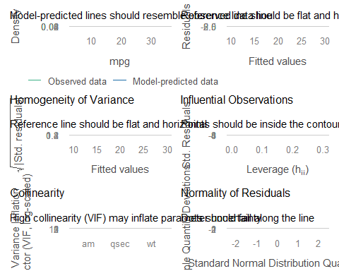

Question
What is the interpretation of the final model?
One way to interpret is with a formula:
mpg = beta_0 + beta_1 * wt + beta_2 * qsec + beta_3 * am

Advanced [optional]

Bootstrap confidence intervals
Bootstrapping may be appropriate here because
- The residuals of the final model may not satisfy all of the assumptions
- Stepwise model selection can introduce bias to the usual statistical inference

Find 95% confidence interval for coefficient of wt
# Set up bootstrap
Nbootstrap<- 1000 # 1000 takes half a minute
coeff_wt <-rep(NA,Nbootstrap)
# Perform bootstrap
set.seed(4363)
for(i in seq_len(Nbootstrap)){
usevalues<-sample(seq_along(mtcars$mpg),size=length(mtcars$mpg),replace=TRUE)
bootstrap.sample<- mtcars[usevalues,]
model_full <- lm(mpg ~ ., data=bootstrap.sample)
model_boot <- stepAIC(model_full, trace=FALSE)
coeff_wt[i] <- model_boot$coef["wt"]
}
# Where the coefficient is NA it means the wt variable wasn't selected
# Set NA's to 0
coeff_wt[is.na(coeff_wt)] <- 0
# Histogram
Bootstrap <- data.frame(Coefficient=coeff_wt)
ggplot(Bootstrap, aes(x=Coefficient)) +
geom_histogram(aes(y = ..density..),binwidth = .5)+
geom_density()+
ggtitle("Bootstrapped Coefficients")+
theme_bw()
## Warning: The dot-dot notation (`..density..`) was deprecated in ggplot2 3.4.0.
## ℹ Please use `after_stat(density)` instead.
## This warning is displayed once per session.
## Call `lifecycle::last_lifecycle_warnings()` to see where this warning was
## generated.
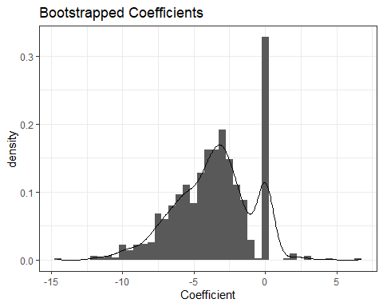
# 95% bootstrap confidence interval
quantile(coeff_wt,c(.025,0.975))
## 2.5% 97.5%
## -9.607137 0.000000

